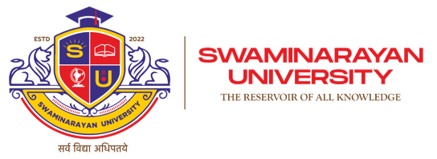
Faculty of Engineering
Department of Computer Engineering

Course Code | ME103106 | Semester | 1
Course Code | ME103106 | Semester | Teaching & Learning Scheme (In Hours Per Semester )
Category | Program Elective II |  | Classroom Instruction |  |  | Extended Learning |  | Total Hours | Total Credits
Category |  |  | L | T | P | TW | SL | HR | C
Course Name | Distributed Systems |  | 48 | 0 | 36 | 26 | 10 | 120 | 4

Course Objectives
- To understand the concepts, architecture, and design principles of distributed systems.
- To develop knowledge of communication, synchronization, and coordination in distributed environments.
- To study distributed computing models, resource sharing, and fault tolerance techniques.
- To implement distributed applications using modern tools and middleware technologies.
- To prepare students for advanced distributed computing applications such as cloud computing, edge computing, and microservices architecture.

Prerequisite
- Basic understanding of computer networks and operating systems.
- Knowledge of data structures and programming concepts.
- Familiarity with database systems and concurrent programming.
- Understanding of client-server architecture and communication protocols.

Syllabus Total Hours: 48 No. of Credits: 3
Unit-1 Introduction to DS:  Introduction to Distributed Systems, Distributed system models, Design issues in DS | 3
Unit-2 Communication in Distributed System  Inter process communication: Message passing model, Remote procedure call and implementation issues, Point to point and Group communication , Client Server model & its implementation, Socket programming, Case Studies: SUN RPC, DEC RPC. | 7
Unit-3 Synchronization in distributed systems:  Introduction, Temporal ordering of events, Clock synchronization, mutual exclusion, Deadlock in distributed systems, Election algorithms. | 8
Unit-4 Remote Method Invocation:  Introduction, Java RMI Architecture, API for Java RMI, Client Callback, Stub downloading. | 3
Unit-5 Common Object Request Broker Architecture:  Introduction, Interface, Inter-ORB Protocol, Object server and object client, Naming service, Object service. | 4
Unit-6 Processes and processors in distributed systems:  Threads, system model, processor allocation, scheduling in distributed systems: Load balancing and sharing approach, fault tolerance, Real time distributed systems, Process migration and related issues. | 11
Unit-7 Distributed File Systems:  Introduction, features & goal of distributed file system, file models, file accessing models, file sharing semantics, file caching scheme, and file replication, fault tolerance, trends in distributed file system, case study HDFS | 8
Unit-8 Distributed Shared Memory:  Introduction, general architecture of DSM systems, design and implementation issues of DSM, granularity, structure of shared memory space, consistency models, replacement strategy, thrashing. | 8
Unit-9 Advanced Topics:  Simple Object Access Protocol, Distributed Computing Paradigm (Message queue system, mobile agent, object spaces) | 5

Term Work Module -26 Hours

Objective
- To strengthen understanding of distributed system concepts through practical implementation.
- To develop skills in communication and synchronization among distributed processes.
- To implement distributed applications using middleware and cloud platforms.
- To analyze fault tolerance, consistency, and scalability issues in distributed environments.

Term Work-1: Introduction to Distributed Systems (4 Hours)

Topics:
- Client-server programming
- Socket communication
- Distributed architecture setup
- Process communication basics

Term Work-2: RPC and RMI Applications (4 Hours)

Topics:
- Remote Procedure Calls
- Java RMI
- Distributed object communication
- Middleware configuration

Term Work-3: Synchronization and Coordination (4 Hours)

Topics:
- Logical clocks
- Mutual exclusion algorithms
- Process synchronization
- Deadlock handling

Term Work-4: Distributed File and Database Systems (4 Hours)

Topics:
- Distributed file access
- Replication techniques
- Distributed transactions
- Database consistency

Term Work-5: Cloud and Virtualization (5 Hours)

Topics:
- Virtual machines
- Docker containers
- Cloud service deployment
- Microservices basics

Term Work-6: Emerging Technologies (5 Hours)

Topics:
- Hadoop and MapReduce
- Blockchain basics
- Edge computing
- Distributed AI applications

Self-Learning Module - 10 Hours

Objective
- To develop independent learning skills in distributed computing technologies.
- To understand modern distributed architectures and cloud platforms.
- To explore emerging technologies such as blockchain and edge computing.
- To strengthen practical and analytical skills for scalable distributed applications.

Recommended Learning

Books
- Distributed Systems: Concepts and Design - George Coulouris
- Distributed Operating Systems - Andrew S. Tanenbaum
- Distributed Systems Principles and Paradigms - Andrew S. Tanenbaum & Maarten Van Steen
- Designing Data-Intensive Applications - Martin Kleppmann
- Cloud Computing - Rajkumar Buyya

Recommended Courses

Distributed Systems & Cloud Courses
- Distributed Systems - NPTEL
- Cloud Computing - Coursera
- Distributed Computing - edX
- Microservices Architecture - Coursera

Programming & Tools
- Java Network Programming - Coursera
- Docker Essentials - IBM
- Kubernetes Basics - Google
- Hadoop Tutorials

Advanced Topics
- Blockchain Fundamentals - Coursera
- Edge Computing - edX
- Big Data Analytics - NPTEL

Learning Resources

Text Books
- Distributed Systems - George Coulouris
- Distributed Operating Systems - Andrew S. Tanenbaum
- Designing Data-Intensive Applications - Martin Kleppmann
- Cloud Computing - Rajkumar Buyya

Reference Books
- George Coulouris - Distributed Systems: Concepts and Design
- Andrew S. Tanenbaum - Distributed Operating Systems
- Martin Kleppmann - Designing Data-Intensive Applications
- Maarten Van Steen - Distributed Systems
- Rajkumar Buyya - Cloud Computing Principles and Paradigms

Practical Total hr: 36
- Socket Programming using TCP/UDP.
- Implementation of RPC/RMI Applications.
- Distributed Mutual Exclusion Algorithms.
- Clock Synchronization Algorithms.
- Distributed File System Simulation.
- Distributed Database Operations.
- Docker Container Deployment.
- Cloud Service Configuration.
- Hadoop MapReduce Applications.
- Microservices-based Application Development.
- Blockchain-based Distributed Ledger Demo.
- Edge Computing Application Setup.

Teaching-Learning Process / Pedagogy

1. Overall Pedagogical Approach
- Theoretical explanation of distributed system concepts
- Communication and synchronization techniques
- Practical implementation using modern tools
- Real-world distributed application case studies

2. Teaching Methods

a) Interactive Lectures
- Distributed system architecture
- Communication protocols
- Fault tolerance and scalability concepts

b) ICT-Based Teaching
Use of tools like:
- Java
- Python
- Docker
- Kubernetes
- Hadoop

c) Problem-Solving Sessions
- Synchronization algorithms
- Distributed communication problems
- Consistency and replication issues

d) Experiential Learning
- Distributed application development
- Cloud deployment exercises
- Big data processing tasks
- Case studies

e) Collaborative Learning
- Group assignments
- Seminar presentations
- Distributed application discussions

f) Project-Based Learning (PBL)
Students develop mini-projects such as:
- Distributed chat application
- Cloud-based file sharing system
- Blockchain voting system
- IoT distributed monitoring system

g) Self-Learning / Flipped Classroom
- Pre-study using NPTEL and Coursera lectures
- Classroom discussions and coding sessions

COURSE OUTCOME
CO No. | Course Outcome | Bloom’s Level
CO1 | Understand distributed system concepts and architectures
CO2 | Apply communication and synchronization techniques in distributed systems
CO3 | Analyze distributed applications for scalability, consistency, and fault tolerance
CO4 | Develop distributed applications using modern distributed computing tools

MAPPING WITH PROGRAM OUTCOME
CO No. | PO1 | PO2 | PO3 | PO4 | PO5 | PO6 | PO7 | PO8 | PO9 | PO10 | PO11 | PO12 | PSO1 | PSO2 | PSO3
CO1 | 3 | 2 | 1 | 2 | 3 | 1 | 1 | 1 | 1 | 1 | 1 | 2
CO2 | 3 | 3 | 2 | 2 | 3 | 1 | 1 | 1 | 2 | 1 | 1 | 2
CO3 | 3 | 3 | 3 | 3 | 3 | 1 | 1 | 1 | 2 | 2 | 1 | 3
CO4 | 3 | 3 | 3 | 3 | 3 | 1 | 1 | 1 | 2 | 2 | 2 | 3

COPO MAPPING JUSTIFICATION FOR MATHEMATICAL FOUNDATION OF COMPUTER SCIENCE

PO1(Engineering Knowledge): Apply the knowledge of basic sciences and engineering fundamentals to solve engineering problems.
PO2(Problem Analysis): Analyze the complex engineering problems and give solutions related to chemical & allied industries.
PO3(Design/ development of solutions): Identify the chemical engineering problems, design and formulate solutions to solve both industrial & social related problems.
PO4(Conduct investigations of complex problems): Design & conduct experiments, analyze and interpret the resulting data to solve Chemical Engineering problems.
PO5(Modern tool usage): Apply appropriate techniques, resources and modern engineering & IT tools for the design, modeling, simulation and analysis studies.
PO6(The engineer and society): Assess societal, health, safety, legal and cultural issues and their consequent responsibilities relevant to professional engineering practice.
PO7(Environment and sustainability): Understand the relationship between society, environment and work towards sustainable development.
PO8(Ethics): Understand their professional and ethical responsibility and enhance their commitment towards best engineering practices.
PO9(Individual and team work): Function effectively as a member or a leader in diverse teams, and be competent to carry out multidisciplinary tasks.
PO10(Communication): Communicate effectively in both verbal & non-verbal and able to comprehend & write effective reports.
PO11(Project management and finance): Understand the engineering and management principles to manage the multidisciplinary projects in whatsoever position they are employed.
PO12(Life-long learning): Recognize the need of self education and life-long learning process in order to keep abreast with the ongoing developments in the field of engineering.

Mapping With Sustainable Development Goals
 |  | SDG Mapping for - Distributed System( ME103106)
SDG No. and Title | Relevance to Course | Justification
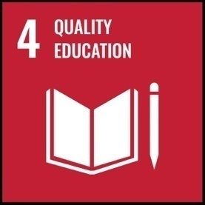 |  | The course provides knowledge of scalable and modern computing technologies for advanced education and research

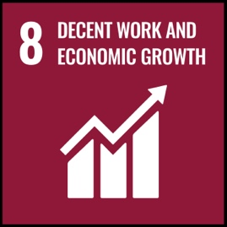
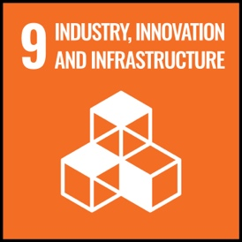 |  | The course contributes to efficient computing infrastructure and distributed digital services.
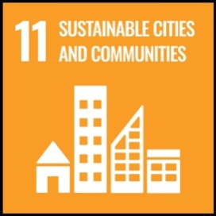 |  | Distributed applications support smart city and IoT-based services.
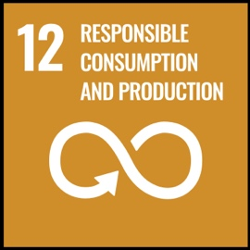
 |  | Efficient distributed computing reduces resource consumption and improves sustainability.
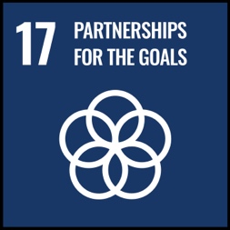 |  | Distributed systems enable global connectivity and collaborative technology development.

